

[Date]

**IR Proximity Sensor Project Final Report**

CIE 301

Ahmed Salah 202200212

Ahmed Mohamed 202200977

Ahmed Mohamed Nasr 202200294

Ahmed Gamal 202200133

Mohamed Ghaith

DR: NEhad

**1. Theory of the Project**

An IR proximity sensor operates by utilizing a pair of infrared light-emitting diodes (LEDs) and a photodiode. The IR LEDs emit infrared radiation, which propagates through the air. When this light strikes an object, it reflects back toward the photodiode. The photodiode absorbs the energy from the IR radiation, converting it into a small electrical current. The magnitude of this current is directly proportional to the amount of IR radiation falling on the photodiode.

This current is converted into a voltage using Ohm's law (V = IR). The voltage output is used to control a connected LED and buzzer, which are activated based on the magnitude of this voltage. In this system, the more IR light that reflects back (due to proximity of an object), the higher the resulting voltage.

To ensure accurate detection and operation, the IR photodiode is connected in forward bias with a resistor between its negative terminal and ground. An IR LED is connected in reverse bias with a 10kΩ resistor, with its positive terminal connected to ground. This setup ensures consistent IR light emission and detection. Note that black objects, which absorb IR light, will not reflect IR radiation and therefore will not trigger the sensor.

The system includes an LM358 IC used as a comparator. The comparator compares the voltage at the photodiode with a reference voltage set using a potentiometer. If the voltage at the non-inverting input (pin 3 of LM358) exceeds the reference voltage at the inverting input (pin 2 of LM358), the output at pin 1 is activated. The potentiometer allows the reference voltage to be adjusted for calibration purposes.

To address noise issues, a low-pass filter was added to the circuit. Based on spectrum and network analysis, the cutoff frequency was determined to be 10 kHz. Simulations in LTSpice demonstrated that the filtered output is approximately 4V, which is sufficient for the system’s operation. The clean output signal is then connected to both the LED and buzzer, enabling obstacle detection.

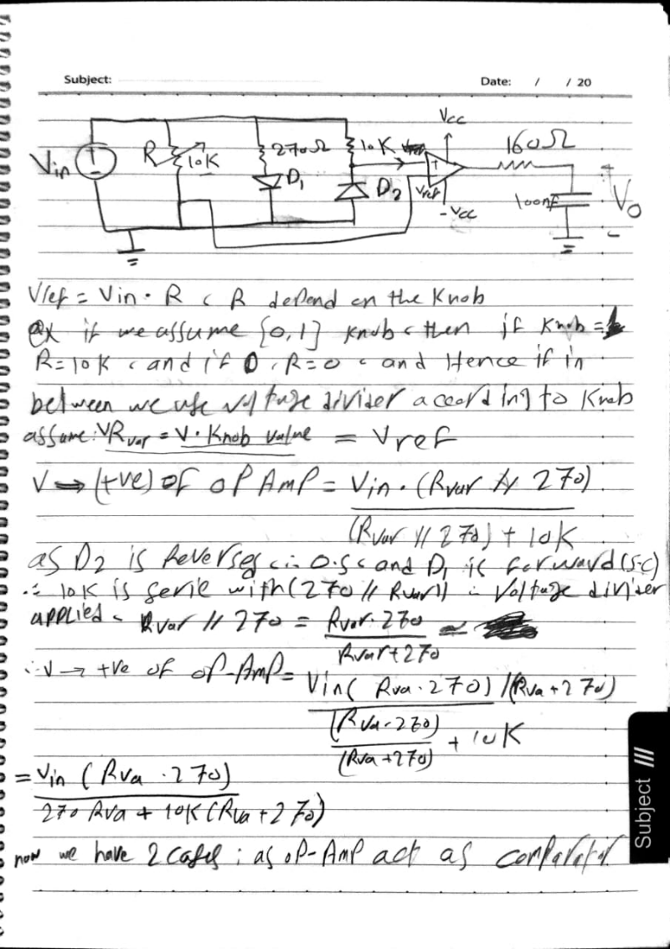**2. Hand Analysis**



**3. Simulation Parts**

**Circuit Simulation**

The sensor circuit, including the IR photodiode, IR LED, LM358 comparator, and low-pass filter, was simulated in LTSpice. Below are the key simulation results:

1. **Spectrum and Network Analysis**:
   * Analysis before the filter indicated significant noise in the signal.

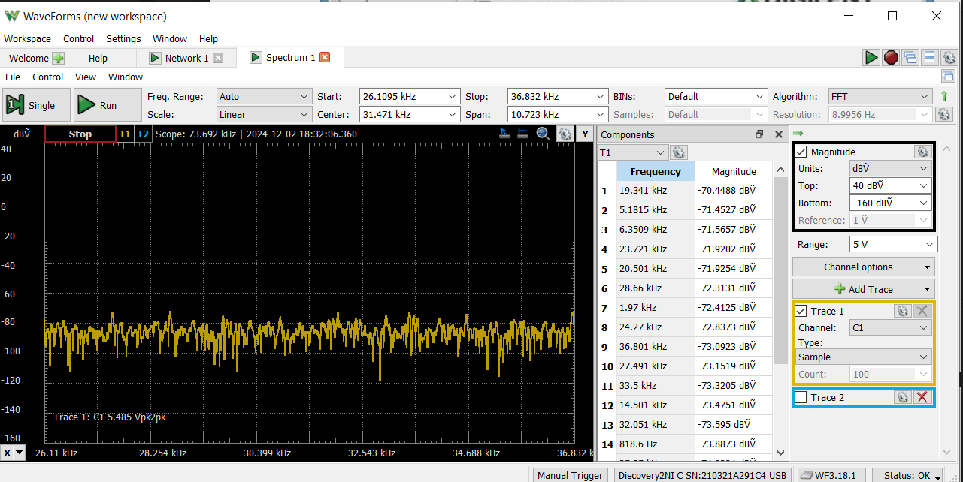

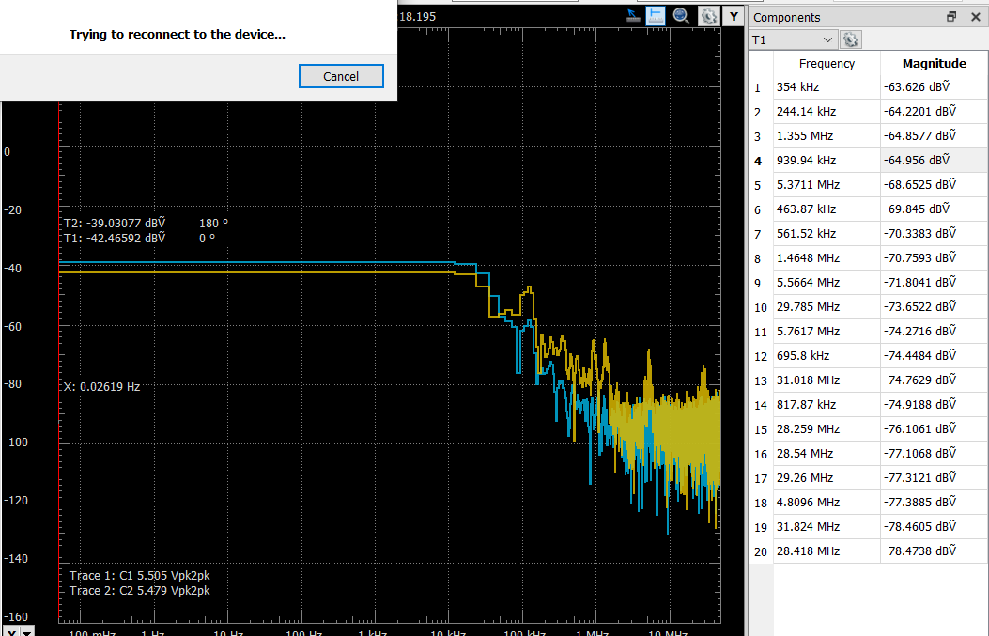

* + Analysis after applying the low-pass filter (cutoff frequency: 10 kHz) showed a clean signal suitable for the application. “Channel 2” which appears in the blue spectrum in upper left image, the drop was to show that it works correctly when detecting obstacles.

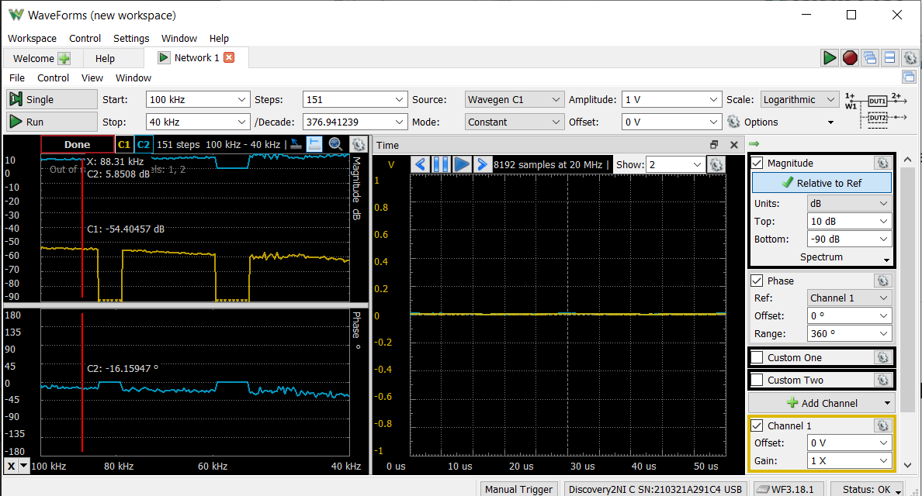

1. **LTSpice Simulations**:
   * **Before the Filter**: Noise and high-frequency components were visible in the output signal.

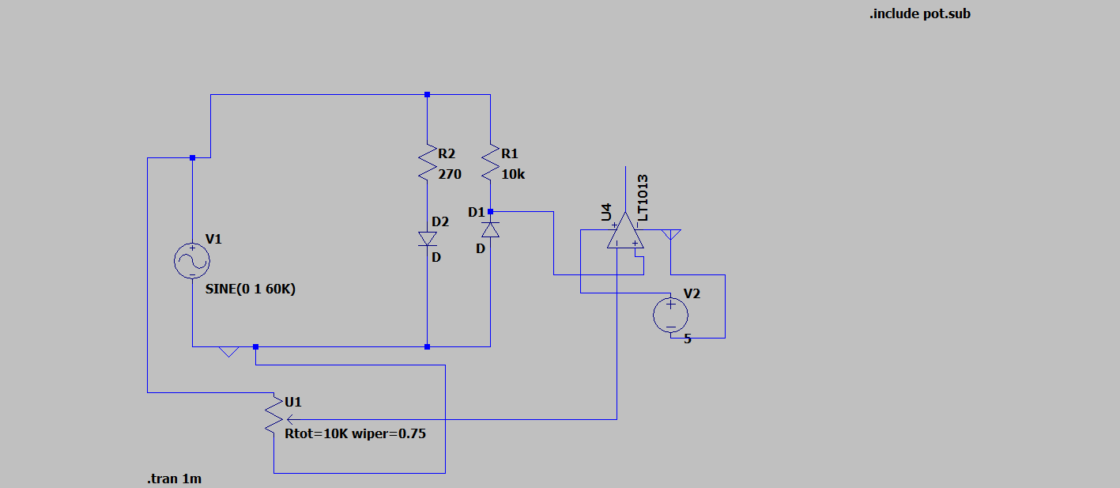

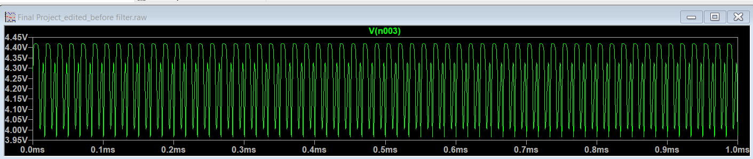

* + **After the Filter**: The output signal was stable at approximately 4V.

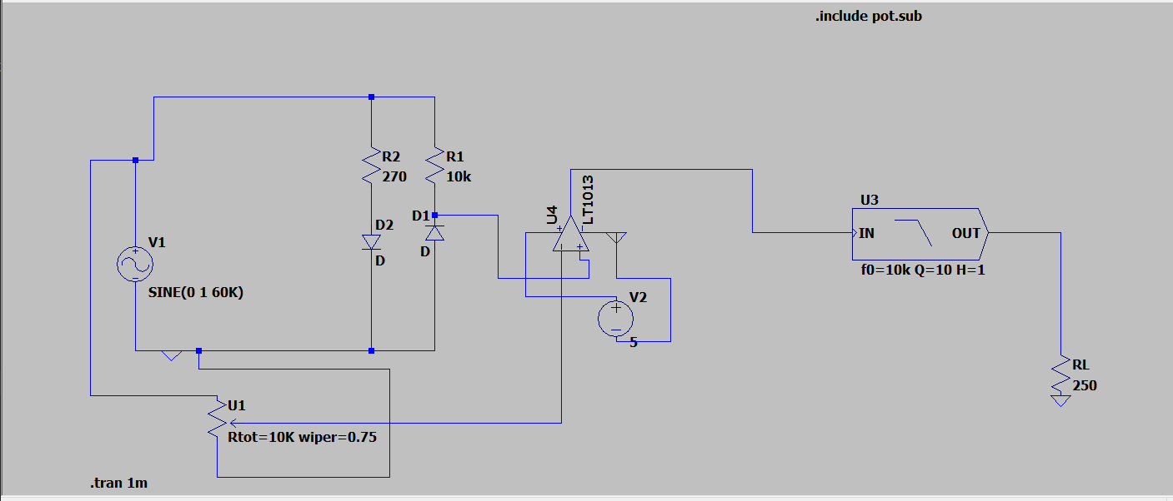

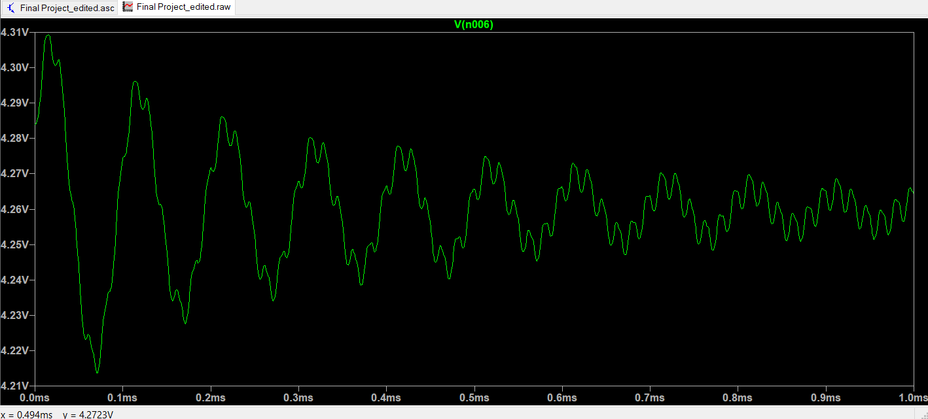

**4. Connections**

**Circuit Connections**

1. **IR LED**:
   * Positive terminal connected to ground through a 10kΩ resistor.
   * Negative terminal connected to the photodiode.
2. **IR Photodiode**:
   * Positive terminal connected to the non-inverting input (pin 3) of the LM358 IC.
   * Negative terminal connected to ground through a resistor.
3. **LM358 IC**:
   * Pin 4 connected to ground.
   * Pin 8 connected to Vcc.
   * Pin 2 (inverting input) connected to the potentiometer's output terminal.
   * Pin 3 (non-inverting input) connected to the IR photodiode.
   * Pin 1 (output) connected to the low-pass filter.
4. **Potentiometer**:
   * One extreme terminal connected to Vcc.
   * Other extreme terminal connected to ground.
   * Center terminal (adjustable output) connected to pin 2 of the LM358 IC.
5. **Low-Pass Filter**:
   * Input connected to the output (pin 1) of the LM358 IC.
   * Output connected to the LED and buzzer in parallel.
6. **Output Components**:
   * LED and buzzer connected in parallel to the low-pass filter's output.

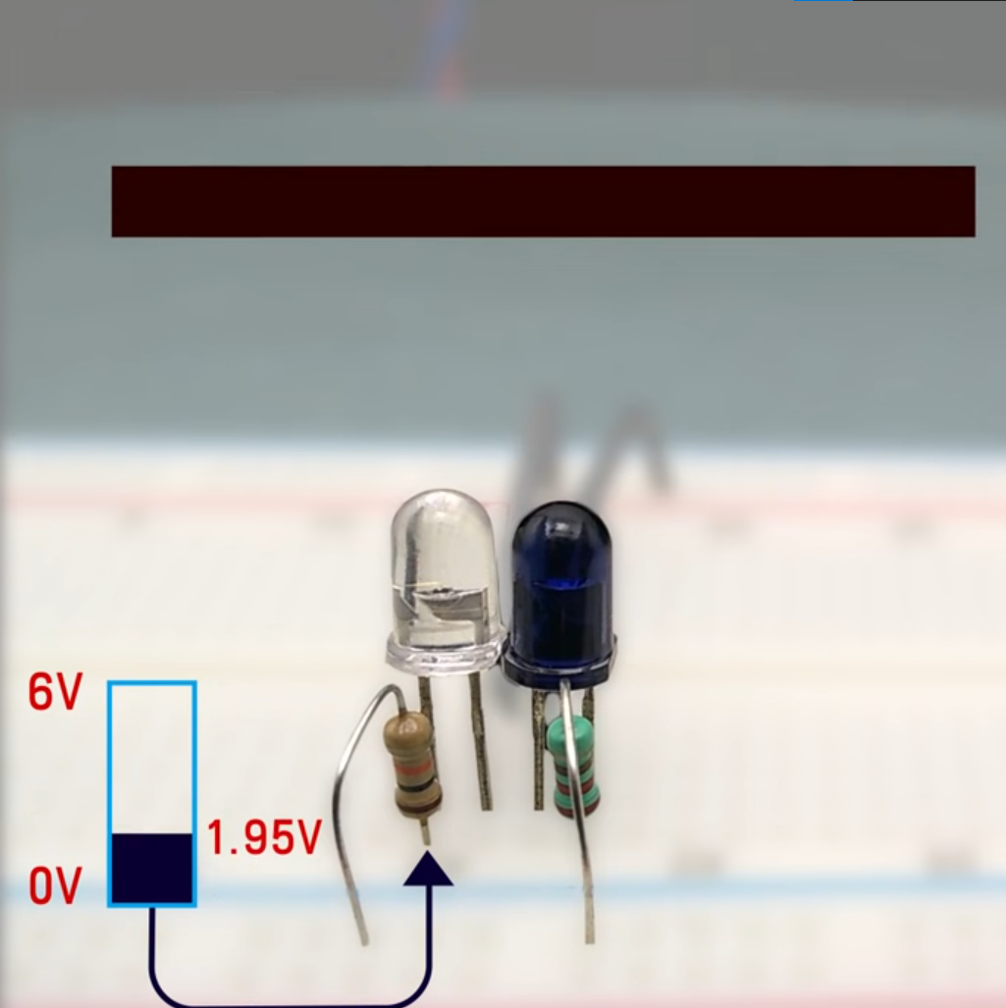 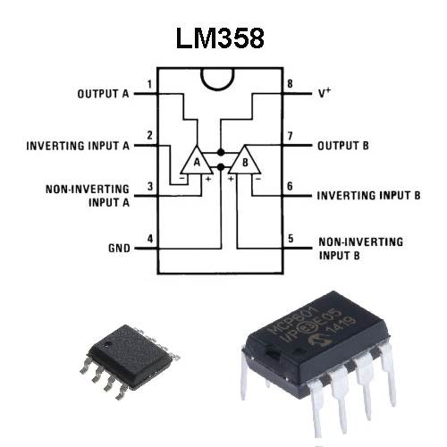 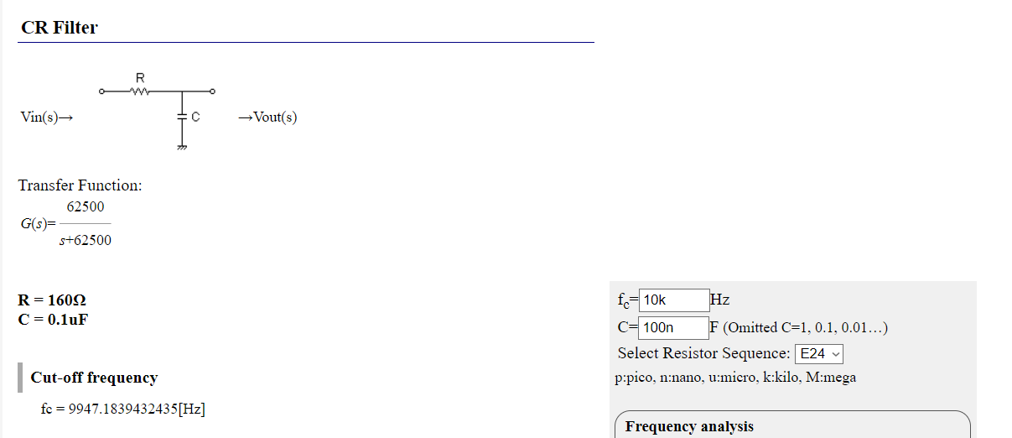

**5. Results**

**Simulation Results**

The LTSpice simulations confirmed that the system functions as intended:

* The low-pass filter effectively removed noise, producing a stable signal.
* The LM358 comparator activated the output correctly when the photodiode voltage exceeded the reference voltage.

**Hardware Results**

The hardware implementation verified the simulation findings:

* The sensor successfully detected obstacles within its range.
* The LED and buzzer activated appropriately when the output voltage surpassed the reference voltage.

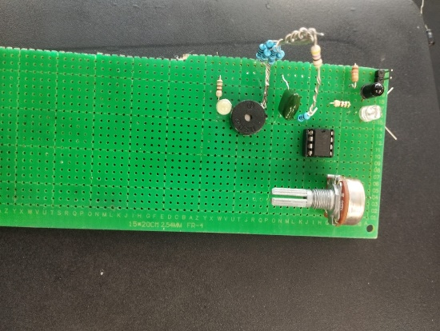 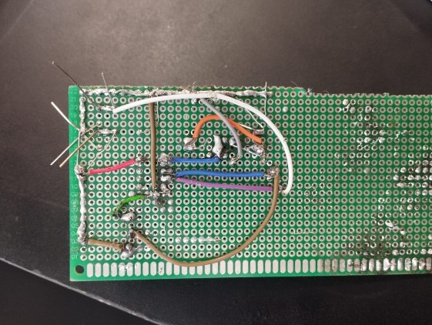

**6. Bonus**

In addition to the main functionality, an extra feature was incorporated into the project. A GPS module and GSM module were integrated with an Arduino to enable location sharing via SMS. This feature operates as follows:

1. A push button is connected to the Arduino.
2. When the user presses the push button, the GPS module retrieves the current location.
3. The GSM module sends the location via SMS to a predefined phone number.

This feature enhances the project’s usability, especially for safety applications.

**Components and Setup**

* GPS module connected to the Arduino for location tracking.
* GSM module connected to the Arduino for SMS transmission.
* Push button connected to trigger the location-sending functionality.

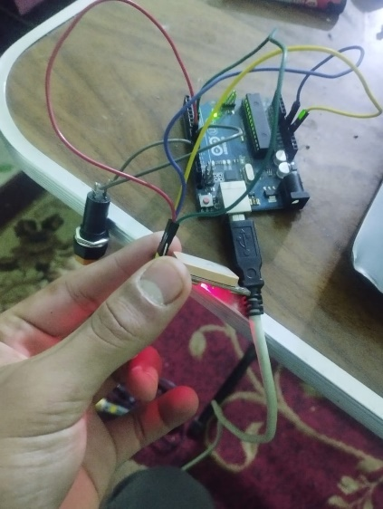

**Code and Output**

